**Problem Introduction**

Two of India's biggest stock exchanges BSE and NSE, collectively clear trades combining to greater than 40,000 crores every day. As you might already be aware, a lot of trading happens on the basis of technical and fundamental analysis.

One of the most basic technical analysis used by a lot of stock traders is the Moving Average Method.

Consider the following price trend of a particular stock.

Week 1: 13,14,11,17,19

Week 2: 26,23,22,22,14

Week 3: 17,19,13,16,17

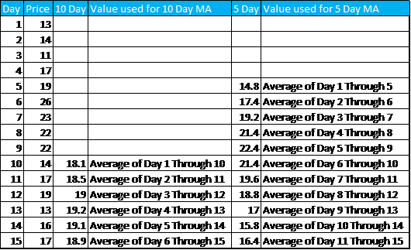

**Moving Average**

As you can see, Moving average use the past data to smoothen the price curve. For the purpose of this assignment, we will be using 20 Day and 50 Day moving averages.

Now that you know about the concept of Moving average, you shall be wondering how to use it to determine whether to buy or sell a stock.

When the shorter-term moving average crosses above the longer-term moving average, it is a signal to **BUY**, as it indicates that the trend is shifting up. This is known as a Golden Cross.

On the opposite when the shorter term moving average crosses below the longer term moving average, it is a signal to **SELL**, as it indicates the trend is shifting down. It is sometimes referred to as the Death Cross.

Please note that it is important that the Moving Averages Cross each other in order to generate a signal. Merely being above or below is not sufficient to generate a signal.

When the signal is neither buy nor sell, it is classified as hold. If you already own the stock, keep it and if you don't then don't buy it now.

# Data Set

The dataset provided here has been extracted from the NSE website. The Stock price data provided is from 1-Jan-2015 to 31-July-2018 for six stocks Eicher Motors, Hero, Bajaj Auto, TVS Motors, Infosys and TCS.

Please note that for the days where it is not possible to calculate the required Moving Averages, it is better to ignore these rows rather than trying to deal with NULL by filling it with average value as that would make no practical sense.

Create a new schema named 'Assignment'

Import the CSV files in MySQL, naming the tables as the name of the stocks.

**[MySQL Assignment Dataset](https://cdn.upgrad.com/UpGrad/temp/c1c2d84e-d196-4c92-90f3-b93de86be373/Assignment.zip" \o "Assignment.zip" \t "_blank)**

[file\_download](https://cdn.upgrad.com/UpGrad/temp/c1c2d84e-d196-4c92-90f3-b93de86be373/Assignment.zip" \o "Assignment.zip" \t "_blank)**[Download](https://cdn.upgrad.com/UpGrad/temp/c1c2d84e-d196-4c92-90f3-b93de86be373/Assignment.zip" \o "Assignment.zip" \t "_blank)**

## Results Expected

1. Create a new table named 'bajaj1' containing the date, close price, 20 Day MA and 50 Day MA. (This has to be done for all 6 stocks)

|  |  |  |  |
| --- | --- | --- | --- |
| Date | Close Price | 20 Day MA | 50 Day MA |

2. Create a master table containing the date and close price of all the six stocks. (Column header for the price is the name of the stock)

The table header should appear as below:

|  |  |  |  |  |  |  |
| --- | --- | --- | --- | --- | --- | --- |
| Date | Bajaj | TCS | TVS | Infosys | Eicher | Hero |

3. Use the table created in Part(1) to generate buy and sell signal. Store this in another table named 'bajaj2'. Perform this operation for all stocks.

|  |  |  |
| --- | --- | --- |
| Date | Close Price | Signal |

4. Create a User defined function, that takes the date as input and returns the signal for that particular day (Buy/Sell/Hold) for the Bajaj stock.

5. Write a brief summary of the results obtained and what inferences you can draw from the analysis performed. (Less than 250 words to be submitted in a pdf file)

**You will be required to submit the commented a zip file consisting of a SQL file and pdf file describing the key observations and summary in under 250 words that you can make from the results.**